Lao Business Forum
Transitioning for a sustainable future

by

Thipphaphone Vongsay

Presented at the Public-Private Dialogue 2010 Workshop
(Vienna, June 1-3 2010)

- Context and particularities of the partnership

Introduction

The Lao Business Forum (LBF) was established in March 2005, through an agreement (MOU) between the Government of Lao PDR and the International Finance Corporation (IFC). The project aims to improve the business enabling environment by providing a platform for a structured and ongoing public-private dialogue between the Government and the business community. IFC serves as the Secretariat for the Forum working alongside the Ministry for Planning and Investment (MPI), which plays the coordinating role on behalf of the government, and the Lao National Chamber of Commerce and Industry (LNCCI) and various associations that represent the business community.

Objectives

The objectives of the LBF are to:

- Facilitate ongoing dialogue between the Government and the Private Sector (PS)
- Promote consistent enforcement and non-discretionary interpretation of laws and regulations
- Remove barriers that businesses face with regard to entry and exit
- Provide feedback and inputs on various Government policies affecting the private sector
- Assist the Government to develop the Private Sector

Six forums have been convened since its establishment. The LBF Secretariat facilitates communications and coordinates interactions between various parties, and is under the direct management of IFC. Specifically, the main tasks of the LBF Secretariat are to:

- Ensure smooth functioning and enhance the effectiveness of the LBF and the working groups.
- Develop good working relations between the working groups and government counterparts to resolve issues raised by the private sector.
- Ensure that the LBF fully represents the views and issues of the business community through a dialogue between the business community and the government.
- Ensure effective dissemination of information generated from the LBF to all members, the Government and donor community to encourage a more complementary public and private sector relationship in Lao PDR.
- Facilitate meetings of the private sector working groups and inter-ministerial team for the purposes of identifying and selecting issues to be raised through the dialogue process.
- Assist the Government in coordinating responses and decision making in regard to issues raised by the private sector and addressed through the dialogue process.
- Build capacity of LBF participants by providing training in public-private dialogue processes and facilitating visits to forums in neighboring countries (eg. Vietnam Business Forum) to exchange experiences.

- Structure and process of the LBF

This section summarizes the structure, process and roles of participating agencies of the Lao Business Forum and their interactions.

LBF structure under IFC management (2005-2009)

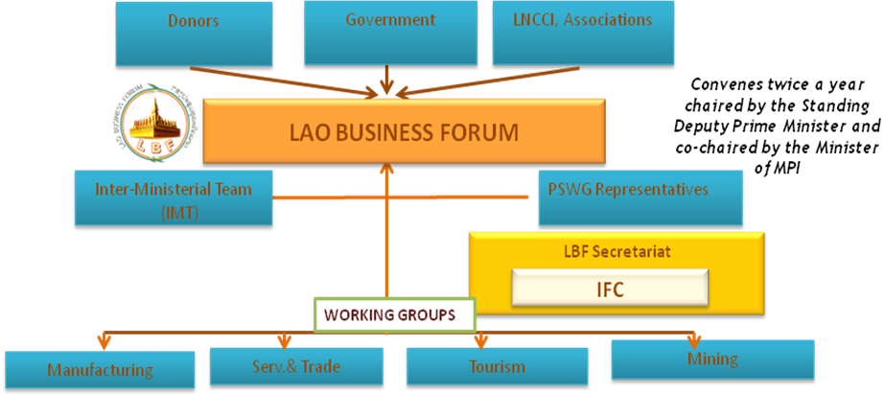

The Private Sector Working Groups
At the operational level, the Private Sector Working Groups (PSWGs) are made up of businesses in four sectors including:
  - Tourism WG
  - Services and Trade WG (several sub-working groups under this WG including Banking and Finance, Import-Export and Customs, insurance, Intellectual Property Rights and Education)
  - Manufacturing WG and
  - Mining WG

The PSWGs meet regularly during the six-month period between each Forum to discuss and raise issues. These issues are then consolidated and presented to the Government Inter-Ministerial Team (IMT) during the working group (WG) meetings. PSWG meetings are open to all private sector representatives interested in participating.

Inter Ministerial Team (IMT) and Private Sector Working Groups
The IMT-PSWGs are the “engine” of the LBF. Each WG is co-chaired by a senior government official and a designated leader chosen by members of the respective PSWG. Participants in each WG are comprised of IMT members from relevant ministries as well as private sector representatives from the PSWGs. The joint Government-Private Sector Working Group Meetings or IMT-PSWG Meetings held once before each Forum takes place to discuss progress of outstanding issues, select new issues and discuss preparation needed for upcoming Forum including tentative date of the Forum.

Sub-Working Group Dialogue
Once the issues are debated and jointly prioritized, they are discussed in the Sub-Group Dialogue by the appropriate IMT and PSWG leaders. When the teams arrive at a mutually agreed solution, it is presented at the LBF.

Semi-Annual Forum (Lao Business Forum)
Twice a year, co-chaired by the Deputy Prime Minister and Minister of MPI, the LBF holds a formal public-private dialogue which brings together Ministers, Deputy Ministers, key relevant government officials and some 300 business leaders, government officials, journalists and development partners. At the forum the WGs present their prioritized issues and possible solutions. The Forum gives the private sector an opportunity to inform top-level government officials of progress on issues discussed and to identify issues that remain unresolved.

The Lao Business Forum Secretariat
The LBF Secretariat, entirely run by the IFC since its establishment in 2005 until February 2010, provides secretariat and coordinating functions for the four Working Groups.

The secretariat, which works in close collaboration with the counterparts that represent the government and private sectors (Investment Promotion Department of MPI and Lao National Chamber of Commerce and Industry (LNCCI) respectively), facilitates dialogue within and among joint government/private sector Working Groups, and broadly between the Government and the business community.

In addition to facilitating Working Groups meetings and the main forums, the secretariat also monitors and records progress in resolving the issues the Working Groups have raised with their Government counterparts throughout the dialogue process.

For the past five years, with IFC support, the Lao Business Forum has been a very useful tool for improving the business environment and it is the only formal mechanism in Laos for companies or individuals who want to raise business related problems with the Government and seek solutions to them.

- Results of the Lao Business Forum

In the Formal Evaluation of the Mekong PPDs in 2007 the assessment demonstrates a strong, measurable economic impact of the three PPD and confirmed that the partnerships have important measurable economic impact in term of private sector savings. Two reforms led by the Lao Business Forum have been estimated to generate impact of US$ 2.7 M in term of cost savings to the private sector. These reforms include 1) Increase of trucking weight limit (US$ 2.4 M) and 2) Fixed entry fee of US$ 1 per tourist (US$ 300 K).

The LBF evaluation also noted other successes as follows:

- Significant reforms can be attributed, at least in part, to the LBF
- The dialogue process is seen in and of itself as a positive outcome for the reform process, and for many respondents, as a significant achievement.
- The LBF has opened communication and advocacy channels which did not exist before, as well as expanding pre-existing channels to new groups, allowing reform issues to be considered, accelerated and successfully processed by the Lao PDR government.
- The Lao PDR government uses public-private dialogue to improve its own communication, coordination and internally accountability.
- While large trends in investor confidence and growth cannot be attributed (positively or negatively) to the LBF, analyses suggest that sub-indicators of business climate effectiveness are positively influenced by the Forum.

In a review of WBG support to structured PPD for private and financial sector development in 2009, of the 30 PPD supported by the WBG world wide, the Lao Business Forum was rated among the high performing PPDs.

According to the review, three particularly influential factors in determining the LBF’s success are:
- The political will of Government to make reform happen;
- An efficient and effective Secretariat as the dialogue’s “engine”; and
- The selection of Working Group participants (key drivers of the private sector)

Throughout the Lao Business Forum, a number of reforms have been achieved as following:

- The recent promulgation of the revised Minerals Law in 2009 (passed by the National Assembly in December 2008).
- Intellectual Property Law (passed by the National Assembly in 2007)
- Revision of rules on tax deductibility of business expenses such as travel, training, etc.
- Extension of tourist visas on arrival from 2 weeks to one month
- Prime Minister notice No. 405 on the implementation of CIQ (Customs, Immigration and Quarantine) issue in March 2007 reduces the number of government agencies involved in import and export inspections as well as documentation requirements.
- Notice No. 31, reforming the system of quotas on timber as input to wood-based manufacturing businesses, and
- Approval of the resolution for the establishment of a Tourism Marketing and Promotion Board in 22 December 2009.

- Exit Strategy and LBF Transition

Given the maturity of the dialogue between the Government and Private Sector as well as the private sector’s capacity in engaging directly with their Government counterparts, following the fifth Lao Business Forum, on February 23, 2009 IFC started working with stakeholders on an exit strategy by commissioning a change management consultant to work closely with the government and private sector and relevant stakeholders including other development partners to ensure the long-term sustainability of the PPD process by transferring secretariat functions from IFC to a relevant local institution. For this reason, we have initiated the process of transferring the secretariat functions of the LBF from IFC to the Lao National Chamber of Commerce and Industry (LNCCI). Initial activities included an independent comprehensive consultation with active stakeholders on the transition process. The consultation, which took place from April to June 2009, built a consensus among key stakeholders on the transition plan to be carried from the signing date of an MOU between IFC and LNCCI (October 2009) until end of 2010. Through 2010, during the transition period, IFC is still supporting the secretariat team at the LNCCI and the MPI as a focal agency for the government.

Structure of the LBF under LNCCI management (from 2010 onwards)

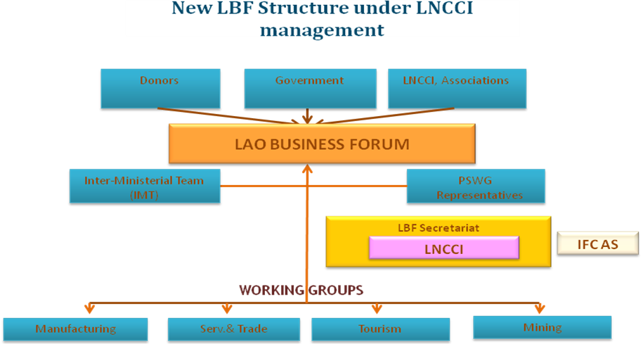

It should be noted that under the new structure of the LBF, the whole dialogue process, existing roles and responsibilities of key stakeholders remain unchanged, except for the LNCCI who will fully engage in the management of the LBF Secretariat functions given that IFC disengaging in the operational functions of the Secretariat. Hence, the only significant change and new to the structure is the shift of the Secretariat functions from IFC to the local institution (LNCCI).

LBF Transition
With IFC’s grant support to help set up a new Secretariat office at the LNCCI the new LBF LNCCI Secretariat office was officially launched with the LBF Secretariat functions successfully transferred from IFC to the LNCCI in February 2010. An LBF coordinator was recruited by LNCCI to perform the day-to-day operational activities of the new secretariat and play active coordination roles with key partners and relevant stakeholders in order to maintain the effectiveness and momentum of the dialogue process. Alongside, IFC will provide backup support to LNCCI through 2010 by assisting its LBF coordinator and the private sector working groups to effectively coordinate activities in order to ensure a seamless transition.

Approach and Timeline

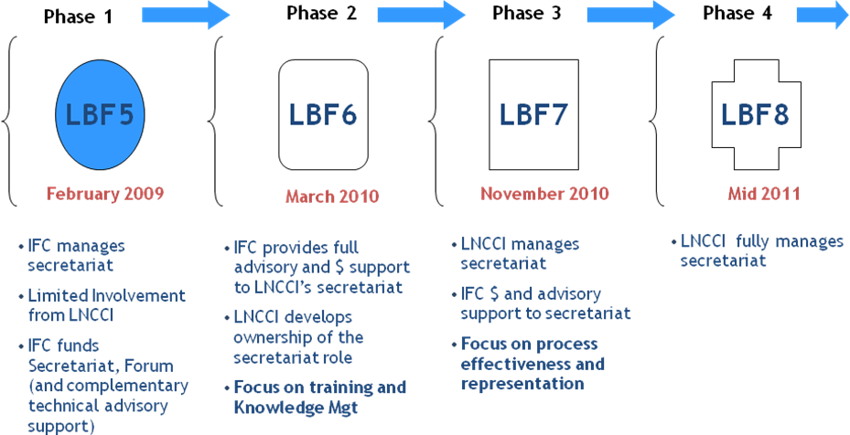

The transition strategy for the LBF has clearly set out roles and responsibilities of LNCCI and IFC with continued support from MPI as the coordinator for the government. Following the 6th Lao Business Forum held on March 5, 2010, LNCCI has developed and taken ownership of the secretariat role by leading the preparation and organization of the Forum with full support from IFC’s LBF transition management team. This early engagement in the management of the LBF process showed strong commitment of the new LNCCI secretariat team. In addition, this early engagement has been a good example of capacity building and knowledge management efforts to support the new LBF secretariat in LNCCI to take on its new role as coordinator of the Forum.

IFC will continue to support this transition process by sharing our experience with the new team at LNCCI and by actively supporting the LNCCI secretariat to enhance its capacity to take on this new role. This will include advisory and financial support for the preparation and organization of the 7th LBF in late 2010.

Beyond 2010 and going forward, IFC will refocus its resources to other aspects of the LBF (i.e. capacity building, policy research, legal framework consultations, etc.).

- Challenges

With the ongoing implementation of the transition strategy, the challenges are to:

- ensure that the secretariat has adequate capacity to help the private sector to identify and formulate sound policy or regulatory issues (Quality of issues raised);
- strengthen trust and respect in the PPD process;
- engage as many PS sectors as relevant to actively participate in the PPD to make certain that the PS has a wide representation, especially, expanding and increasing SMEs representation; and
- Most importantly, to ensure the financial sustainability of the LNCCI in running the LBF Secretariat following from 2011 onwards.

- Lessons learned

Maintain participation and commitment from all sides:

Government and LNCCI
- Government commitment and leadership were demonstrated by delegating key/high ranking officials to actively participate in the LBF transition strategy consultation process.
- LNCCI’s willingness and commitment to take on Secretariat function was a key factor, particularly under their role as advocate for the PS.
- LNCCI’s contribution of resources to support the continuation of the PPD by appointing staff and allocating office space for setting up a local secretariat office not only shows commitment but also bodes well for the long-term sustainability of the LBF.

Private Sector
- Private sector was catalyst and supporter of the transition.
- Private sector possesses strong willingness to move to a new phase of the PPD.
- Private sector’s commitment to the PPD process and recognition of its value and significance has helped transition process with common objectives.

Process
- Transition benefitted from having an independent facilitator to support the change management process by gathering recommendations, ensuring all voices were represented and providing unbiased recommendations.
- Strong consensus that LBF Secretariat should be transferred and managed by a local institution and that LNCCI is the right place to manage the secretariat function.
- IFC’s commitment to the future success of the PPD through financial support, knowledge sharing, and backstopping support are needed throughout the transition period.
- Key lesson learned is that it is easier and more effective to initiate transition at a stage when Forum is maturing but not to wait too long to the point where IFC Secretariat is too entrenched and stakeholders feel too dependent on IFC. LBF Secretariat transition from IFC to LNCCI took place after about 5 years of IFC running the Secretariat. This provided enough time to build up the LBF and stakeholder interest and capacity but was not too long to the point that stakeholders were unable/unwilling to adapt to change.

Author’s biography

Ms. Thipphaphone Vongsay
Ms. Thipphaphone Vongsay (Thippy) is a project officer for the Lao Business Forum project of the IFC’s Mekong Investment Climate Advisory Program. She joined IFC in 2005 working as a project officer for Business Edge program and in 2007 for the Tourism program in Lao PDR. Thippy has two years experience as an Assistant Auditor at PriceWaterhouseCoopers and one year experience as Coordinator for a pre-shipment inspection company – Societe Mixte D’inspection Lao BIVAC International, Bureau Veritas. She holds a Master’s degree in Economics of Development from the Australian National University (ANU) and Bachelor’s degree in International Economics from Chulalongkorn University in Bangkok, Thailand. Thippy is Lao National. Contact: tvongsay@ifc.org

